Part 1

1. Find the output of the following program

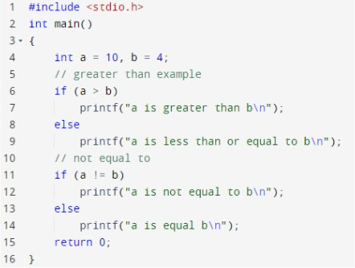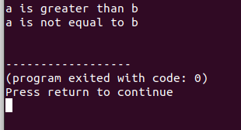

1. Find the output of the following program

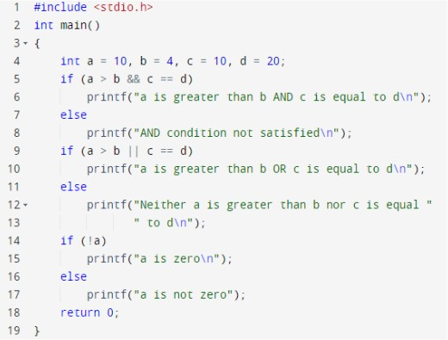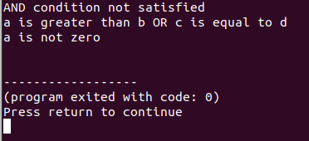

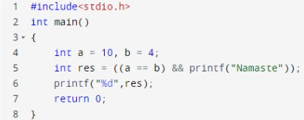

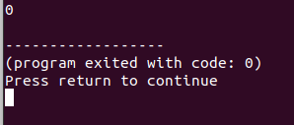

Since 10 != 4 the “AND” gate has the value “0” for False and didn’t print Namaste.

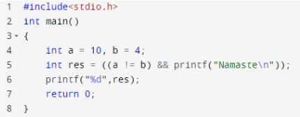

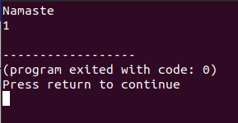

The statement a!=b have been verified true as 10!=4 and the AND gate has been true so it printed Namaste and the res value for true I.e 1.

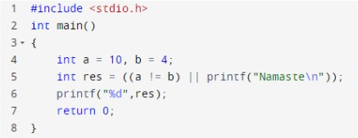

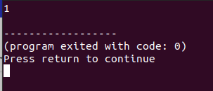

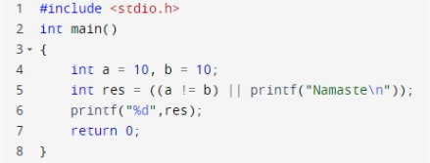

Question 5 and 6 uses the truth table A OR B

|  |  |  |
| --- | --- | --- |
| A | B | A V B |
| 1 | 1 | 1 |
| 1 | 0 | 1 |
| 0 | 1 | 0 |
| 0 | 0 | 0 |

Using this, only if statement A is false the Statement B is executed.

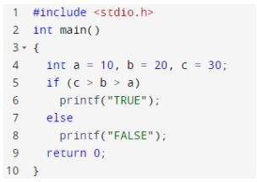

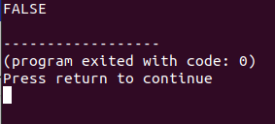

Over here c>b>a is executed as (c>b)>a there for c>b return true : (true)>a. The int value for true is 1 so 1>a which is false.

Therefore the else part of the if else block is executed.

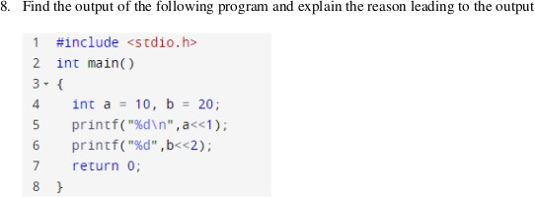

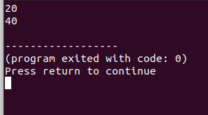

A=10 in binary 10 = 1010 then a<<1 is left shift once. Therefore the new binary value of a is 10100 I.e 20 in decimal.

B=20 in binary 20 = 10100 then b<<2 is left shift Twice. Therefore the new binary value of b is 101000 I.e 40 in decimal.

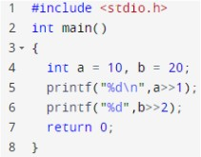

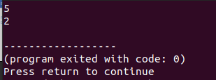

A=10 in binary 10 = 1010 then a>>1 is left shift once. Therefore the new binary value of a is 101 I.e 5 in decimal.

B=20 in binary 20 = 10100 then b>>2 is left shift Twice. Therefore the new binary value of b is 10 I.e 2 in decimal.

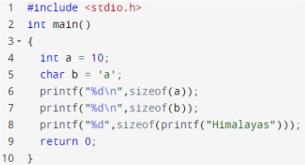

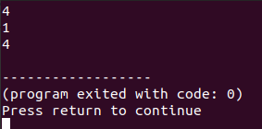

The bit size int is 4 and char is 1 and the string “Hamalayas” is 4.

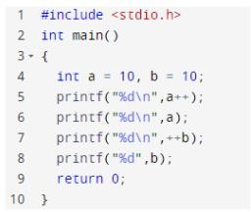

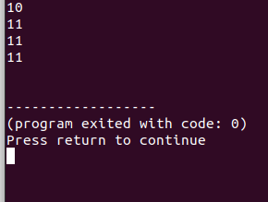

In printf <variable name>++ means the value of the variable is printed then incremented. And ++<variable name> means the value is incremented then printed.

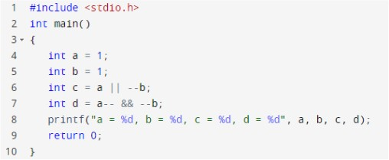

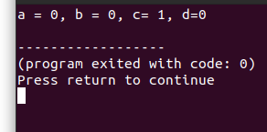

In line 6 c= a OR - - b if a == 0 then b. so c=1

In line 7 d= a - - && - - b which is 1 decremented to 0 AND b is decremented to 0. therefore a=0,b=0,d=0

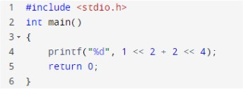

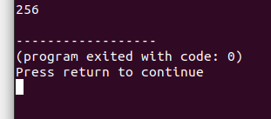

1<<4<<4 so in binary 01<<4<<4 = 10000<<4 =100000000 converting to decimal 256.

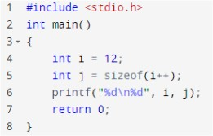

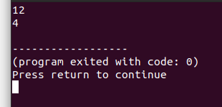

I=12 j=size of int which is 4

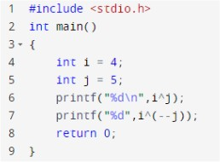

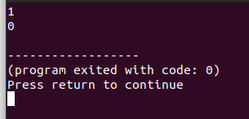

4 bitwise XOR 5

0100

0101

-

0001

Therefore I^j =1

And I^(j-1) = 4^4 =0 (bitwise XOR of same number is 0)

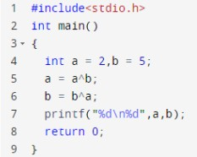

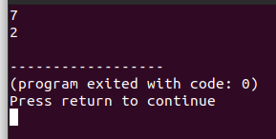

a=a^b = 2 bitwise XOR 5 = 010 ^ 101 = 111 = 7

b=b^a = 5 biteise XOR 7 = 101 ^ 111 = 010 = 2

17. Given the code to swap two variables without a third variable using + and – operators. Can you try to write a code to swap variables without using a third variable using the ^ Operator.

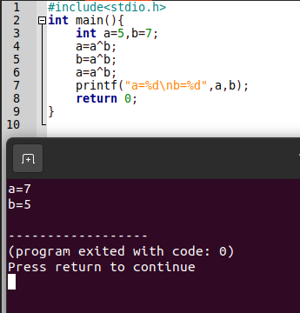

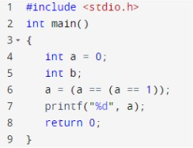

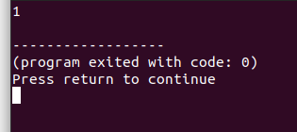

a=(a==(a==1)) a=(a==0)

a=1

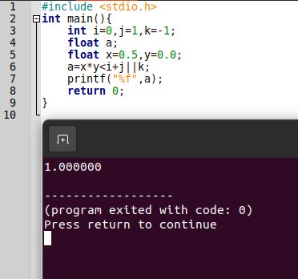

A=x*y<I+j||k; A=0.5*0.0<0+1||-1 A=0<1||-1

A=1||-1 A=1

1. Which BITWISE operator is to be used in line number 7 for the value in variable ‘c’ to be 6? What

is the value in variable ‘z’?

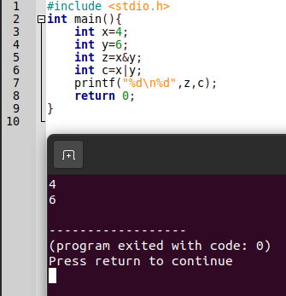

4|6 = 0100 | 0110 = 0110 = 6

1. Akshay and Rohith are playing a game. The game is such that Akshay has to find out the number in a series of 5 numbers which are given by Rohith (all the numbers are greater

than 0). Now, out of the 5 numbers only one number is not a duplicate of any other number,

i.e every other number except one number has a duplicate. Help Akshay write a program that finds the number not having a duplicate and displays the same as the output. [Please understand that you are not supposed to use == operator or loops or an array(s) or any built in function other than printf and scanf)]

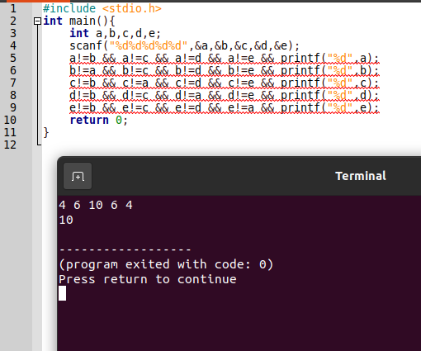

1. Nivedita and Hima are playing a game to determine whether a number mentioned by Hima is even or odd. However, Nivedita is not supposed to use /, %, - or + operators. Help

Nivedita to write a program that can determine whether the number mentioned by Hima is even or odd

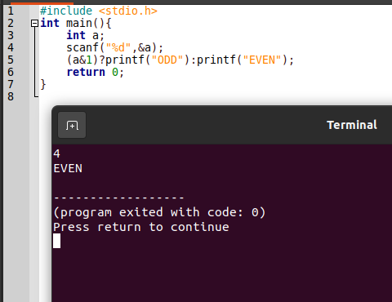

1. Find the output of the following program and explain the reason leading to the output

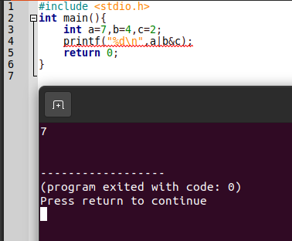

7|4&2 = 7|0110&0010 = 7|0010 = 7|2 = 0111|0010 = 0111 = 7